Technical Design Template

Team: | Phantom | ITN: | 1 |  |  | Solution Design
 |  | Pipeline(s):
  MH1

Solution Design 1
Pipeline(s): 1
1 Introduction 1
1.1 Link to Requirements Document 1
1.2 Requirements 1
User Story 1
2 Design Discussion 2
2.1 Use Case 2
2.2 Class Diagrams 2
3 Implementation 3
3.1 Files 3
4 Testing Considerations 10
5 Screenshots 11

Introduction
This is a web-based application used to manage the contacts for a firm. The contacts are stored in a secure location on an internal server and the user is able to log in to the system using their access details.
The user can perform CRUD operations based on the privileges provided to them by the administrator.

Link to Requirements Document
https://jira2.cerner.com/browse/DEVACDMY-5165

Requirements
.

User Story
User Story ID | MH1
Story | Launch the application by signing in
Description | The user is allowed to use the application after the system authenticates the user provided access details.

Design Discussion

Use Case

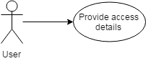
Figure 1 Use Case for user authentication

Class Diagrams
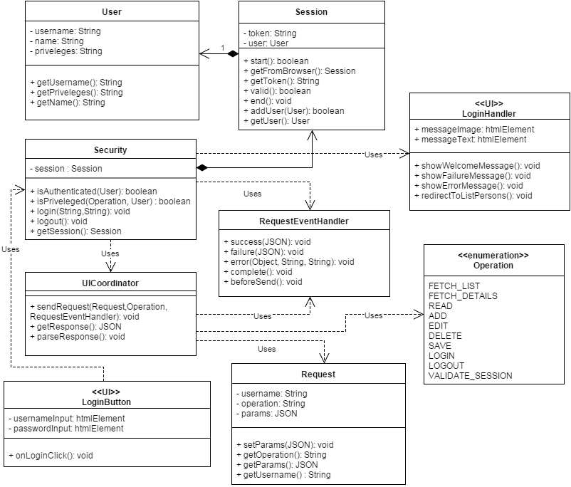

Figure 2 Class Diagram for Login Authentication

Implementation

This user story is to build an authentication portal from where the user gets access to the application. The implementation details are detailed as follows:

- The user is able to enter the username and password into the respective fields on a web form.
- The access credentials are encrypted and sent over to the server-side ‘login.php’ script through an AJAX call using HTTP POST request.
- The server takes the credentials and verifies them from the database by querying the list of registered users and their and login credentials.
- On successful authentication, the session variables are set and the appropriate privileges are assigned to the user. The user is redirected to the dashboard page where the user can add, view, update or delete contacts and their details.
- If authentication is not successful, the user is shown an appropriate error message and asked to re-enter the credentials.

Files

3.1.1 HTML

File | login.html
Description | This is the html page that shows the form for entering the username and password. On clicking the login button, it sends an AJAX http request to “login.php” on the server to verify the login details.
Passive (Yes/No) | No

3.1.2 CSS

File | css/style.css
Description | This is the css file for the “login.html”. It describes the styles for each and every html element present in the login page.
Passive (Yes/No) | No

3.1.3 JAVASCRIPT

File | scripts/js/LoginButton.js
Description | The class that defines the click event of the login button
Pseudo Code | function onLoginClick(){  username = getUsername();  password = getPassword();  Security().login();  }  }
Passive (Yes/No) | Yes

File | scripts/js/Request.js
Description | This class contains the requested operation from a particular user and the parameters required for the operation.
Passive (Yes/No) | Yes

File | scripts/js/RequestEventHandler.js
Description | This class is an interface for the functions to be fired depending upon the resulting event of the request.
Pseudo Code | Class RequestEventHandler {  function success();  function failure ();  function error();  function complete();  function beforeSend();  }
Passive (Yes/No) | Yes

File | scripts/js/User.js
Description | This class is the definition of a real-user of the application and contains user-related info like username, name, priveleges etc.
Passive (Yes/No) | Yes

File | scripts/js/Session.js
Description | This is the class that store the current session and the user associated with the session
Pseudo Code | function valid(){  request = new Request();  validateSessionEventHandler = new RequestEventHandler();  coordinator = new UICoordinator();  coordinator.sendRequest(req, validateSessionEventHandler );  if(validateSessionEventHandler.success)  return true;  else  return false;  }  }
Passive (Yes/No) | Yes

File | scripts/js/Security.js
Description | This class is responsible for authentication and validating session and priveleges. It sends a request to the server for login() and logout() respectively
Pseudo Code | function login(username, password){  new Request();  loginEventHandler = new RequestEventHandler();  loginEventHandler.success = function(response){  loginHandler = new LoginHandler();  msg = response.message;  if(response.status == 'success'){  session = new Session().start(response.data.session.token, mUser);  // show welcome message  loginHandler.showWelcomeMessage(msg);  // redirectToHome  loginHandler.redirectToListPersons();  }  coordinator = new UICoordinator();  coordinator.sendRequest(request, loginEventHandler );  }  }
Passive (Yes/No) | Yes

File | scripts/js/UICoordinator.js
Description | This is the php script that has the function login() which receives the encrypted username and password. It connects to the MySQL database and matches the credentials from the database. On unsuccessful authentication, it returns an appropriate error response.
Pseudo Code | function login($username, $password){  new Request();  database = getDatabase();  SQL query = “form sql query”;  database.fetchResults();  if ( numResults == 0){  message( ‘Wrong username/password’ );  }elseif (numResults == 1){  Message( ‘Welcome, ’ + NameOfUser );  }else{  Message( ‘More than one user exists with the same username’)  }  }  }
Passive (Yes/No) | Yes

File | scripts/js/LoginHandler.js
Description | This is the php script that has the function login() which receives the encrypted username and password. It connects to the MySQL database and matches the credentials from the database. On unsuccessful authentication, it returns an appropriate error response.
Pseudo Code | function login($username, $password){  new Request();  database = getDatabase();  SQL query = “form sql query”;  database.fetchResults();  if ( numResults == 0){  message( ‘Wrong username/password’ );  }elseif (numResults == 1){  Message( ‘Welcome, ’ + NameOfUser );  }else{  Message( ‘More than one user exists with the same username’)  }  }  }
Passive (Yes/No) | Yes

File | scripts/js/Operation.js
Description | This class defines the constants by which the different operation are identified throughout application
Pseudo Code | class Operation = {  const FETCH_LIST : 'fetchList',  const FETCH_DETAILS : 'fetchDetails',  const READ : 'read',  const ADD : 'add',  const EDIT : 'edit',  const DELETE : 'delete',  const SAVE : 'save',  const LOGIN : 'login',  const LOGOUT : 'logout',  const VALIDATE_SESSION : 'validateSession'  }
Passive (Yes/No) | Yes

3.1.4 PHP

File | scripts/php/Security.php
Description | This is the class that has the function login() which receives the encrypted username and password. It connects to the MySQL database and matches the credentials from the database. On unsuccessful authentication, it returns an appropriate error response.
Pseudo Code | function login(username, password){  new Request();  database = getDatabase();  SQL query = //get user with username and password  database.fetchResults();  if ( numResults == 0){  status = ‘failure’;  message( ‘Wrong username/password’ );  }elseif (numResults == 1){  status = ‘success’;  Message( ‘Welcome, ’ + NameOfUser );  }else{  status = ‘error’;  Message( ‘More than one user exists with the same username’)  }  response = generateResponse();  return response;  }  }
Passive (Yes/No) | Yes

File | scripts/php/DatabaseProvider.php
Description | This class is the provider of database and various procedures on the database.
Pseudo Code | function getDatabase(){  return this.database;  }
Passive (Yes/No) | Yes

File | scripts/php/Operation.php
Description | This class defines the constants by which the different operation are identified throughout application
Pseudo Code | abstract class Operation{  const FETCH_LIST = 'fetchList';  const FETCH_DETAILS = 'fetchDetails';  const READ = 'read';  const ADD = 'add';  const EDIT = 'edit';  const DELETE = 'delete';  const SAVE = 'save';  const LOGIN = 'login';  const LOGOUT = 'logout';  const VALIDATE_SESSION = 'validateSession';  }
Passive (Yes/No) | Yes

File | scripts/php/ServerCoordinator.php
Description | This class is responsible for getting operation requests and parsing the request. The appropriate response is generated and passed onto the UI client.
Pseudo Code | class ServerCoordinator{  private $request;  private $response;  function getRequest(){//.. do something }  function parseRequest(){ //.. do something}  function generateResponse(){//.. do something }  function sendResponse(){//.. do something }  }
Passive (Yes/No) | Yes

File | scripts/php/Session.php
Description | This class is the representation of a real-time session when a user logs in to the application.
Pseudo Code | class Session{  private $token;  private $user;  function start();  function end();  function getToken();  function getUser();  }
Passive (Yes/No) | Yes

File | scripts/php/User.php
Description | This class is the representation of a real-time user on the server-side.
Pseudo Code | class User{  private $username;  private $name;  private $priveleges;  function getUsername();  function getName();  function getPriveleges();  }
Passive (Yes/No) | Yes

Testing Considerations
#Test Cases | Test Steps | Expected Results
TC 1 | - Enter correct username and password.  - Click on the Login button | The user session variables are set and is redirected to the home page.
TC 2 | - Enter incorrect username and password  - Click on the login button | The user is shown an error message saying “Incorrect username/password”
TC 3 | - Shutdown the MySQL server  - Enter any username/password  - Click on the login button | The user should be displayed an error message saying “We cannot process your request”

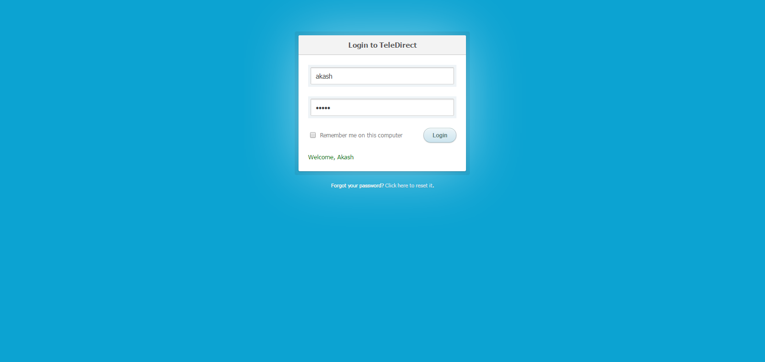
Screenshots
Figure 3 Login Success

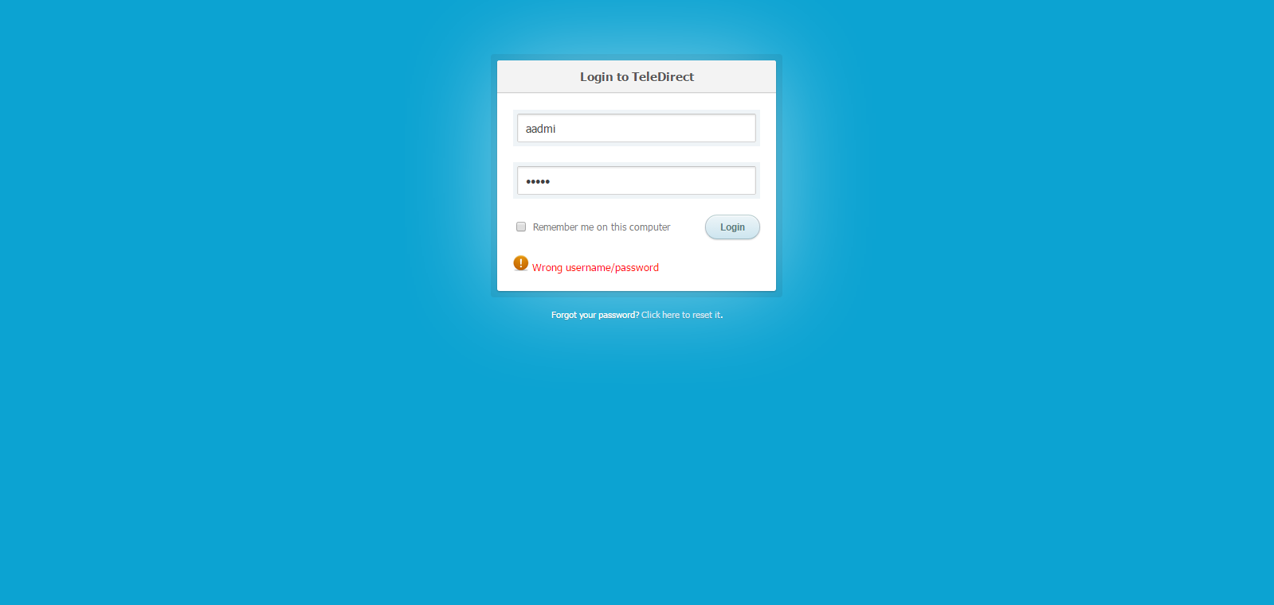
Figure 4 Login Failure

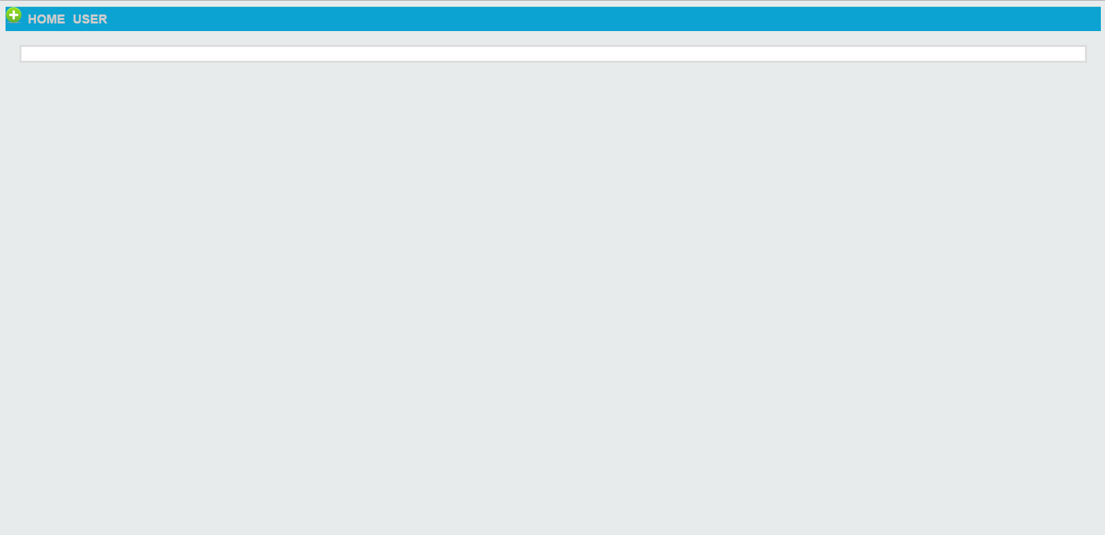
Figure 5 Home Page

